2D Pattern Problem

Instructions:

Show how to extend the Rabin-Karp method to handle the problem of looking for a given **m x m** pattern in an **n x n** array of characters.

(The pattern can be shifted vertically or horizontally, but it may not be rotated).

Students should present a new algorithm for this written on paper in neat writings. Explain all variables clearly.

Example (Reference)is given below to explain what the problem exactly means.

**N X N array of characters**

|  |  |  |  |  |  |  |  |  |  |
| --- | --- | --- | --- | --- | --- | --- | --- | --- | --- |
| A | W | Q | T | R | U | I | J | N | B |
| T | R | U | E | Y | G | T | R | D | E |
| S | E | L | F | J | U | K | L | I | F |
| G | O | O | D | F | G | H | J | K | L |
| S | O | U | L |  | T | R | U | E | R |
| H | Y | T | R | E | S | E | L | F | W |
| K | J | H | Y | T | G | O | O | D | S |
| R | V | H | J | R | S | O | U | L | F |
| R | E | D | C | N | K | L | I | O | P |
| E | V | A | Q | Z | X | L | P | U | Y |

**M x M pattern of characters**

|  |  |  |  |
| --- | --- | --- | --- |
| T | R | U | E |
| S | E | L | F |
| G | O | O | D |
| S | O | U | L |

Solution :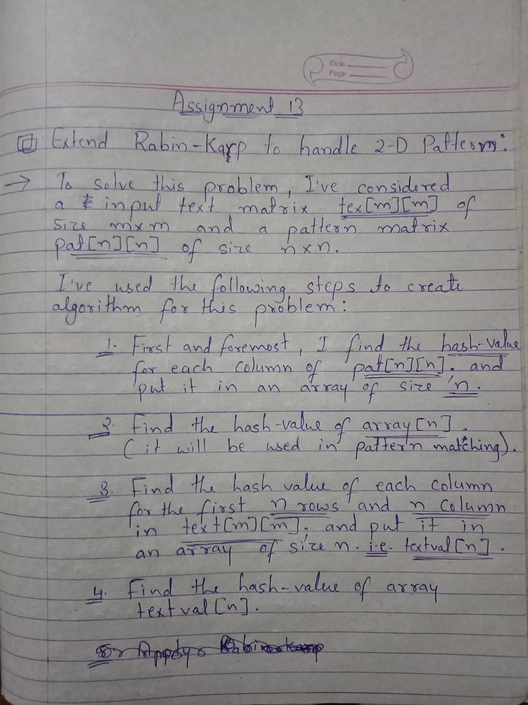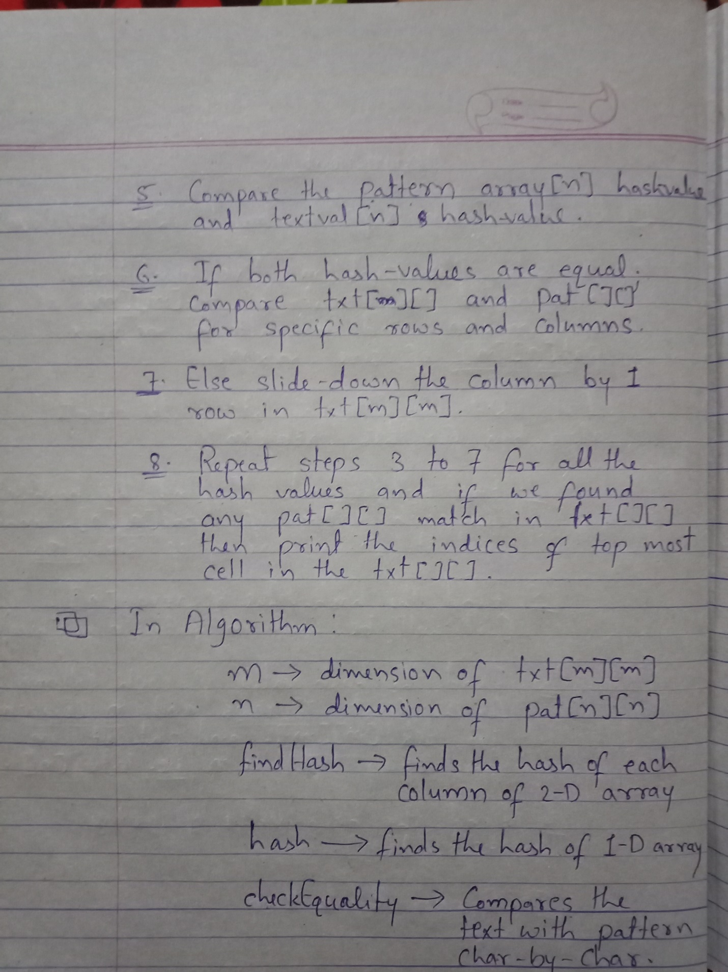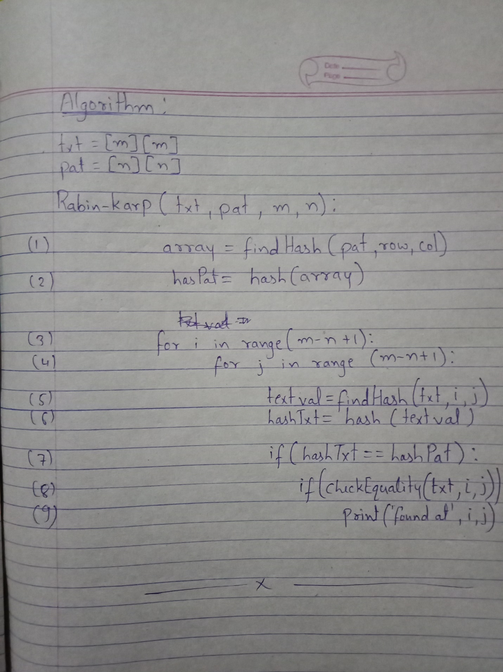

Program (Python) :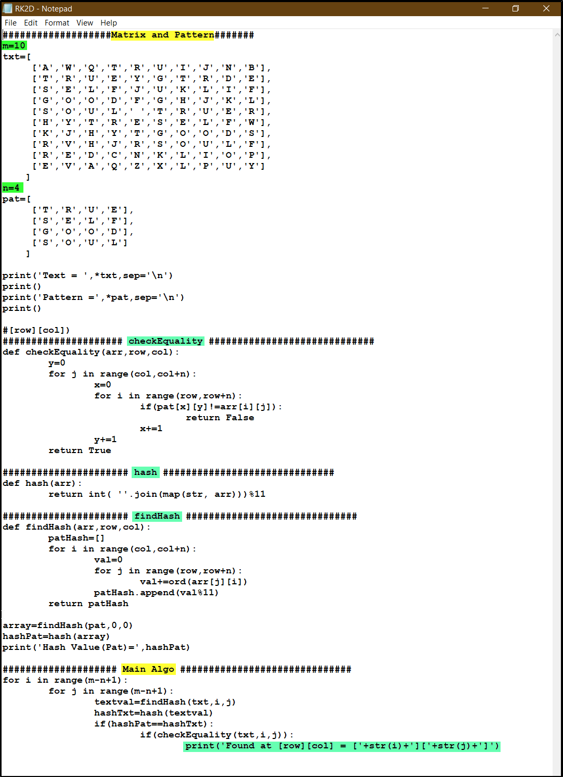

Execution :

